Hashing And Salting
- What’s Hashing
- What are the disadvantages of hashing?
- What's Bcrypt?
- Advantages Bcrypt
- What’s Salting
- Advantages of Salting

Authentication without Sessions
- When choosing a color, ensure it aligns with what is given in the document. And sate why you have use that color (e.g for ppl with color blindness)

“{{}}” Enables you to write python on a html page.

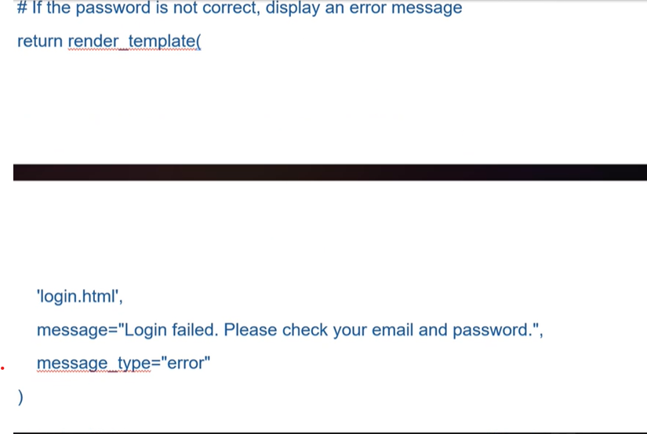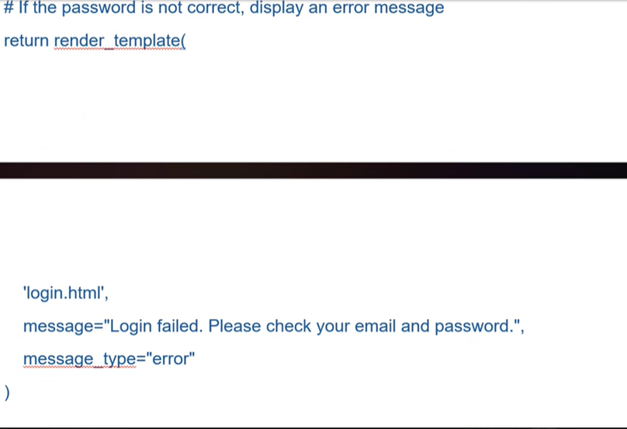Incase you need a database viewer use this extension:


